Individual Skills Competition Basketball Level II
Three events make up the Level 2 Individual Skills Competition: 12 Meter Dribble, Catch & Pass and Perimeter Shooting. The athlete’s final individual score is determined by adding together the scores achieved in each of these three events. Athletes will be pre-divisioned according to their total scores from these three events. Each event is diagrammed with the suggested number and placement of volunteers who will administer them. It is also suggested that the same volunteers remain at an event throughout the competition so that consistency is provided.

Event 1: 12 Meter Dribble
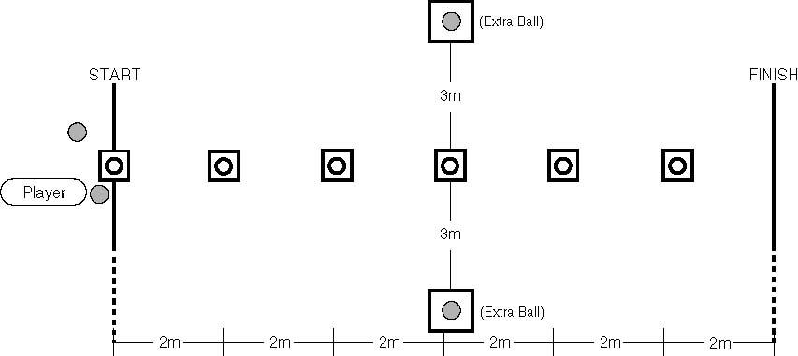

Purpose: To measure an athlete’s speed and skill in dribbling a basketball.

Equipment
A goal, the official NGB free throw lane, floor tape and two basketballs, one that the athlete is provided initially, another that is for back-up in case the basketball bounces away.

Description
- A player is instructed to dribble the ball while passing alternately to the right and to the left of six obstacles placed in a line, two meters apart, on a 12-meter course.
- The player may start to the right or to the left of the first obstacle but must pass each obstacle alternately thereafter.
- When the last obstacle is passed (the final cone), the player will dribble around the cone and back through the slalom passing each obstacle alternately to the right and left. This process is repeated until time is called. A point is received for every midpoint that the athlete crosses.
- The second and remaining balls are all placed on the ground for the returning athlete to retrieve and continue. The player continues until 60 seconds have elapsed. If a player loses
control of the ball, the clock continues to run.
- The player recovers the ball or picks up the nearest back-up ball and may re-enter at any point along the course.
Timing: 60 seconds for one trial.
Scoring
- One point is awarded for every midpoint that the athlete crosses.
- The player must use legal dribbles and must have control of the ball in order to get credit for the midpoint of the cones being successfully passed.
- The player’s score is how many cone midpoints that he/she successfully passes in 60 seconds.
Staging
- Volunteers administer the test and are not to interfere with any player who is performing the test.
- Volunteer A will instruct the group doing this particular test while Volunteer 8 demonstrates the actual test.
- Volunteer A will give a basketball to the player who will take the test, ask him/her if ready, will then say, "Ready", "Go" and will count how many cones the player passes in 60 seconds.
- Volunteers B and C, who are standing behind the extra balls, will retrieve and replace the basketball whenever it goes out of play. Volunteer D will time and record the athlete's score.
- Each volunteer is to administer the test and manage the area only.

Event 2: Perimeter Shooting

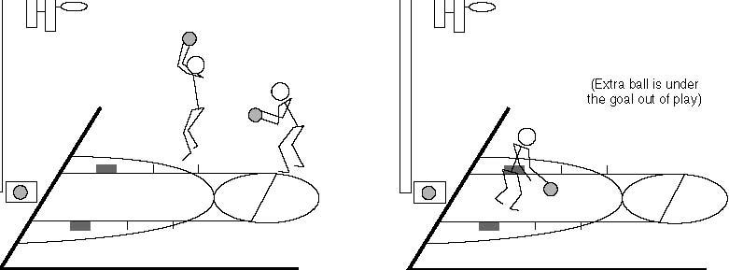

Purpose: To measure an athlete’s skill in shooting a basketball.
Equipment
Floor tape, six cones, and four basketballs, one that the athlete is provided initially, two others that are for back-up in case the basketball bounces away.
Description
- A player stands anywhere along the free-throw line within the free throw
circle.
- The player dribbles toward the goal and attempts a field goal of his/her choice outside the 2.75 meter arc (9 ft.). This attempt must be taken anywhere outside the 2.75 meter arc marked off by a dotted line. [This arc intersects with the free-throw restraining circle].
- The player then rebounds the basketball (made or missed shot) and dribbles anywhere outside the arc before attempting another field goal.
- The player shall make as many field goals as described above in one one-minute trial.
Timing: 60 seconds for one trial.
Scoring: Two points are awarded for each field goal made within the one-minute
trial.
Staging:
- Volunteers administer the test and are not to interfere with any player who is performing the test.
- Volunteer A will instruct the group doing this particular test while Volunteer B demonstrates the actual test.
- Volunteer A will give a basketball to the player who will take the test, ask him/her if ready, will then say, “Ready, Go,” and will count how many field goals the player makes in one minute.
- Volunteer B, who is standing behind the extra ball, will retrieve and replace the basketball whenever it goes out of play. Volunteer C will time and record the athlete’s score.
- Each volunteer is to administer the test and manage the area only.
Event 3: Catch and Pass
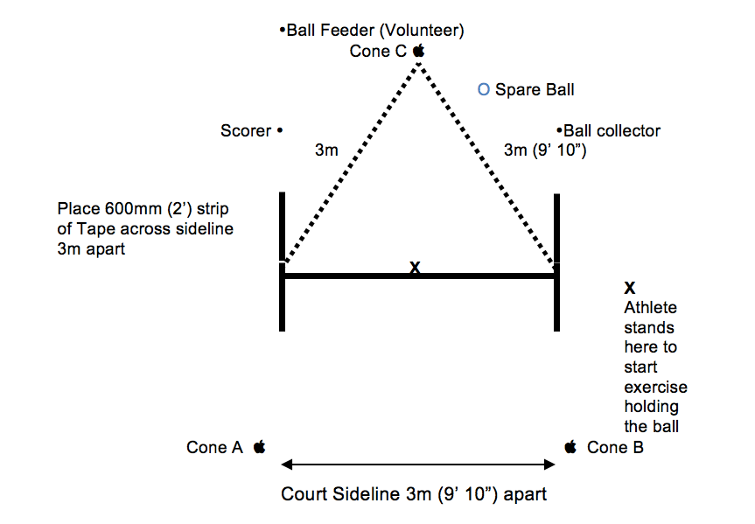
Purpose: to measure an athlete’s skill in passing and catching a basketball.
Equipment
- 3 Cones, 2 Basketballs, Floor Tape, Air horn/Whistle, Score Bench and Clock.
- Two strips of tape 600 millimeter (2 ft.) long are laid across the court sideline three meters apart (9 ft. 10 in) at Cones A & B. Cone C is laid out three meter from each end of the sideline forming a triangle.
- A small cross made of tape is laid in the middle of Cones A and B where the athlete stands holding the basketball ready to begin the exercise.
- The ball feeder stands behind Cone C.
A spare ball is placed near Cone C.
Description
- On go, the athlete passes the ball to the feeder and moves quickly to either cone A or B.
As the player approaches or reaches the end line the feeder passes the ball to the athlete to catch.
- The player MUST have at least ONE foot over the end line at the point of
catching the ball.
- The player must catch the ball, then pass it back to the feeder from behind the end line. One or both feet can be grounded but both must be behind the line at the moment of passing the ball back to the feeder.
- When athlete has passed the ball, they move quickly to the opposite cone to receive the next pass.
- The player continues passing, moving along the line and catching the ball for 60 seconds.
- A bounce pass maybe used with lower ability/less able athletes.
Timing: 60 seconds for one trial.
Scoring
- One point is scored for each good pass made to the feeder (the pass must be catchable).
- One point is scored for each good catch made by the athlete (i.e. no fumbles).
- The athletes must have the ball under control or no point can be scored.

