SPECIAL OLYMPICS PENNSYLVANIA FLOORBALL
RULES & REGULATIONS (Nov. 2025)
Governing Rules
- PA Rules
- International Floorball Federation Rules and Regulations
- SONA Floorball Rules (SONA rules are used, if the rules are not in the PA Rules)
Official Events
- State Event
- Indoor Winter Games in York, PA
- 5v5 Competition
- 4 field players, 1 goalie
- Unified 5v5 Competition
- 3 athletes, 2 partners – 4 players, 1 goalie
Divisioning
- Teams (traditional & Unified)
- All Teams must complete the “Team Rating Form” which can be found in the Floorball Tracker.
- If prelim games are necessary, they will be 7-minute running clock with open substitution; must start top 5 players (including Goalie) for first 3 minutes.
- Individual Skills
- All Skills athletes must submit the total score of the 5 skill events.
- Prelims and Finals will be held at Indoor Winter Games
Roster Size
- Traditional
- 5v5 Team Roster may have a minimum of 10 players (8 players & 2 goalies) and a maximum of 12 players
- Teams may travel with 5 players
- A team must start every game with 5 players. A team may drop below five after the start of the game due to injury or illness but must have 5 to start the game. There must be a minimum of 4 (including Goalie) players on the court.
- Unified
- Unified Roster may have a minimum of five players (3 athletes and 2 partners) and a maximum of 10 (6 athletes and 4 partners)
- Unified 5v5, the minimum ratio will be 2 athletes, 2 partners. If the team cannot meet the minimum ration due to disqualification or injury, the team will have to forfeit the game.
- The goalie can be either an athlete or a unified partner.

Equipment
- Each player will have a Floorball stick, more information on sticks and purchasing can be found here: https://www.floorballplanet.com/
- Ball - 72 mm (2.8") in diameter, and it weighs 23 gm (.89 oz)
- Protective equipment is not required for ages 16+
- Under 16, eye protection is required
- Field players desiring to wear a helmet must wear a soft helmet, this NOT required

- Goalie Equipment
- Goalie equipment is not required but recommended
- Helmet
- Chest padding
- Pants
- Knee pads
- Gloves
- Goals
- 2 goals needed for game play – Goal sits 1.85m from the endline
- 63”x 45” for Indoor Winter Games
      - Please Note – Programs do not need to purchase goals; you may practice with your floor hockey Goals.
- Goalkeeper Area
- 1m x 2.5m box - located in front of goal (see diagram below)
- No field players can step into the goalkeeper area – only sticks can enter
- Face-off Dots
- Face-off dots shall be marked on the center line and on the imaginary extensions of the goal lines one meter from the long sides of the rink. The face-off dots shall be marked as crosses. The dots on the center line may be imaginary.

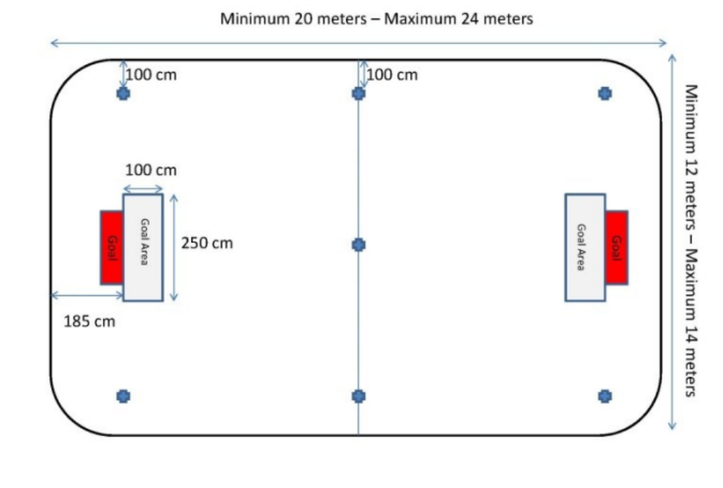

The Game
- Duration
- The game will be played for two 15-minute periods, 2–5-minute halftime
- In Tournament style play 5-10 minutes should be scheduled between each game
- Clock
- Running clock, stoppage after penalties
Substitutions
- Substitution Zones
- The zone shall be marked on both sides of the board (with painters' tape on the border patrol).
- The width of the substitution zones must not exceed three meters, measured from the board.
- The players’ benches shall be placed at an appropriate distance from the board and have sufficient room for all members of the team not on the court, including coaches.
- Player Substitution
- The substitute of players may take place at any time and an unlimited number of times during a match.
- All substitution shall take place in the team’s own substitution zone.
- A player leaving the rink has to be on his way passing over the board before a substitute may enter the rink.
- An injured player leaving the rink outside his own substitution zone must not be replaced until play is interrupted.
Timeouts
- Each team is allowed 1 timeout per game.
- The time out lasts 30 seconds.
Extra Time
- If a match that must be decided ends with a tie, it shall be extended to a maximum extra time of 5 minutes.
- Before extra time, the teams have the right to a 2-minute intermission, but no changing of ends shall take place.
- During extra time the same rules apply to starting and stopping time as during regular game time.
- Penalty time remaining after regular game time shall continue during extra time.
- The first team to score in extra time will win the match.
- If the score is still tied after extra time, the match shall be decided by penalty shots.
Penalty Shots
- Four field players from each team shall take one penalty shot each.
- The penalty shots shall be taken alternately.
- The referees decide which goal to use and shall carry out a draw between the team captains.
- The winner decides which team will start taking the penalty shots.
- The team captain or member of the team staff shall, in writing, inform the referees and the scorekeeper of the numbers of the players and the order in which they will take the penalty shots (sudden victory)
- The referees are responsible for ensuring that the penalty shots are taken in the exact order as noted by the team staff.
- If the score the 8 penalty shots is still tied, The rotation beings again with sudden victory
- If player 1 scores a goal, Player 1 from the opposite team must make a goal to continue penalty shots.
- This continues until a player from one team makes the shot and the corresponding player in the other team’s rotation does not.
- The same four players shall take one penalty shot each until a decisive result is achieved.
- As soon as a decisive result is achieved during the penalty shots, the match is over, and the winning team shall win by one extra goal.

Competition
Starting & Ending Each Period
- Every new period shall start with a face-off from the center spot.
- At the end of every period the scorekeeper is responsible for providing a siren or other suitable sound device, unless this is automatic.
- The timing of the intermission shall start immediately at the end of the period. The teams are responsible for being back onto the rink in time to resume play after the intermission.
Scoring a Goal
- A goal is counted when the entire ball passes the goal line from the front, having been played in a correct way with a field player’s stick, and no offense leading to a free-hit or a penalty has been committed by the attacking team in connection with, or immediately before, the goal. This includes:
- When a player in the defending team has moved the goal cage out of position and the ball passes the goal line from the front between the marks for the posts and below the imaginary position of the bar.
- When an own goal is scored. An own goal may be allowed off the stick or body of the defender.
- If the non-offending team scores an own goal during a delayed penalty, the goal shall be allowed.
- A goal shall be considered allowed when it has been correctly scored and confirmed with a face-off at the center spot.
Face-Offs
- Face-offs are taken at the center spot to begin each period and after a goal is scored.
- A face-off is also taken when play is interrupted and neither team is awarded a hit-in, free hit or penalty shot. The face-off shall be taken at the nearest face-off dot according to where the ball was at the interruption.
- All players, except those taking the face-off immediately take a position at least 3 meters from the ball.
- The stationary ball shall be played with the stick by 1 player from each team. There is no physical contact before the face-off. Feet must be placed perpendicular to the center line and each player must have both feet at the same distance from the center line. Sticks must be held with a normal grip (the way the player holds the stick during play) with both hands above the grip mark on the stick. The blades shall be placed perpendicular to the center line on either side of the ball, but without touching it.
- The defending team chooses which side of the ball to place the stick. If the face-off is at the center line, the visiting team player chooses. The ball shall be at the center of the blades.
- A face-off may go directly into the goal.
Other situations leading to a face-off
- When the ball is damaged unintentionally (usually when somebody steps on the ball)
- When the goal cage is moved unintentionally and cannot be put back in a reasonable time. (It is the goalkeeper’s responsibility to put the goal cage back in position as quickly as possible).
- If a serious injury occurs or if an injured player directly affects play.
- When an unnatural situation occurs during play. For example, an unauthorized person or object enters the rink, lights go out, the horn sounds by mistake, when a broken stick causes a dangerous situation or affects play, or when the ball hits the referee and has a significant effect on the play.
- When a goal is disallowed despite the fact that no offence leading to a free hit has been committed.
- When a penalty shot does not result in a goal.
- When a referee considers their decision incorrect or is unable to decide the direction of a hit-in or free-hit.

Offsides, play stoppages / whistles
- There is no offside rule in floorball which differs from hockey or soccer. This results in a faster game and more dynamic scoring opportunities.
- When play has been interrupted (ball out of play, offence committed, goal scored), play resumes with either a face-off, hit-in, free hit or penalty shot. These are called ‘fixed situations. We will explore these situations in the following slides.
- The referees shall use one signal (whistle), show prescribed signs and mark the place for the fixed situation. The ball may be played after the whistle with no delay if it is not moving and is in the right position.

Hit-Ins
- When the ball leaves the rink or playing surface, a hit-in shall be awarded to the non-offending team. The offending team is considered to be the team whose player, or player’s equipment, last touched the ball before it left the rink.
- A hit-in is taken from where the ball leaves the rink, 1.5m (5 ft) from the board but never behind the imaginary extensions of the goal lines. When the ball leaves the playing area on the short side (behind the imaginary extension of the goal line), the hit-in is taken from the nearest face-off dot.
- When the ball touches the ceiling or objects above the rink, the hit-in should be taken from 1.5m (5 ft) from the board (court sideline) at the same distance from the center line.
- Opponents shall immediately (without a call from the referee) take a position at least 3 meters from the ball. The player taking the hit-in does not have to wait for opponents to take position.
- Then the ball leaves the playing surface, a player from the team taking the hit-in will normally retrieve the ball.
- To perform a hit-in, the ball shall be played with the stick. It shall be HIT, not dragged, flicked or lifted.
- The player taking the hit-in shall not touch the ball again before it has been touched by another player.
- A hit-in may go directly into the goal.
Free-Hits
- When an offense (infraction) leading to a free-hit is committed, a free-hit shall be awarded to the non-offending team.
- Advantage Rule – With offenses leading to a free-hit, the advantage rule shall be applied whenever possible. The advantage rule implies that if the non-offending team still controls the ball after an offense, they shall have the opportunity to continue playing if this gives them a greater advantage than a free-hit. If the advantage is being played and the game is interrupted because the non-offending team loses control of the ball, the resulting free-hit is taken from where the last offense occurred. The referee signals the advantage rule verbally, “advantage” and visually.
- The free-hit is taken where the offense was committed but never behind the imaginary extensions of the goal lines or closer to the goalkeeper areas than 3.5m (11 ft). A free-hit behind the imaginary extension of the goal line shall be taken from the nearest face-off dot. The referee will signal the direction of the free-hit (arm) and indicate the location (foot).
- A free-hit closer to the goalkeeper area than 3.5m shall be moved out to a distance of 3.5m from the outer line of the goalkeeper area along a line from the center of the goal line through the spot that the offense was committed. This leaves .5m for the defending team to form a defense line immediately outside the goalkeeper area and allow for 3m of free space. The attacking team does not have to wait for the defending team to form a defense line and has the right to place their players in front of the line.
- As with a hit-in, opponents shall immediately (without a call from the referee) take a position at least 3 meters from the ball. The player taking the hit-in does not have to wait for opponents to take position.
- The same rules as the hit-in apply to free-hits – how the ball is hit, touching the ball after the free-hit and directing the ball into the goal.

Goalie
- If a team does not have a second goalie and the playing goalkeeper gets injured or penalized with a 2+2, 2+10, or MP, the goalkeeper can be replaced with a field player.
- The team has a maximum of 3 minutes to properly equip the substitute and no warmup time is allowed.
- If the goalie leaves the goalkeeper area (the large box) during play, he shall be considered a field player without a stick.
- Outside the goalkeeper area, the goalie is limited to interacting with the ball the same as a field player, stopping the ball with the chest or leg and playing the ball with the foot.
- Goalie boxes should be properly marked when playing with a goalie.
- The goalkeeper area is protected for the goalie. Offenses include free-hit or penalty shot for a player in the goalkeeper area.
- Free-hits as a result of the goalie’s actions:
- Leaving the goalkeeper area during a throw-out.
- When a field player passively obstructs the goalie’s throw-out.
- When a goalie throws or kicks the ball over the center line.
- When a goalkeeper has the ball under control for more than 3 seconds.
- When the goalkeeper receives a pass or takes the ball from a field player on the same team.

Fouls and Penalties
- Delayed Penalty
- All penalties may be delayed. This happens when the non-offending team still controls the ball after a penalty offense has occurred. The non-offending team is given the possibility of continuing the attack until the offending team plays the ball, takes control of it or play is interrupted.
- A field player for the non-offending team may be substituted for the goalkeeper to provide an additional attacker. If the offending team gains and controls the ball, play shall be resumed with a free hit.
- If the non-offending team scores during a delayed penalty, the goal shall be allowed, and the delayed penalty will not be carried out.
- If the offending team scores during a delayed penalty, the goal shall be disallowed and play resumed with a face-off. If the non-offending team scores an own goal, the goal shall be allowed
- Bench Penalty
- The duration of a bench penalty is 2 minutes. It affects the team strength since the penalized player cannot be replaced on the court during the penalty.
- No more than 1 bench penalty per player and 2 bench penalties per team shall be measured simultaneously.
- If a player who has incurred a bench penalty commits further offenses leading to a penalty, the penalties will be served consecutively.
- If the opposing team scores during a bench penalty, the penalty shall terminate unless the opposing team is playing outnumbered or at even strength
- The offense leading to a penalty shot shall not result in a bench penalty unless the offense is a major bench penalty or a match penalty. In other words, if a penalty shot is awarded, a 2-minute penalty is not.
- A minor bench penalty consists of 1 bench penalty served by the player committing the offense (2 min).
- A major bench penalty consists of 2 bench penalties served consecutively by the player committing the offense (2 min+2 min)

- Minor Bench Penalties - Many of the offenses leading to a minor bench penalty are like infractions leading to a free-hit. In these cases, the penalty is called when the offense is of a more serious nature.
- A player hits, blocks, lifts or kicks an opponent’s stick or body to gain a considerable advantage, or with no possibility of reaching the ball. - If the referee thinks the player otherwise played the ball correctly before hitting the opponent’s stick or body, no action shall be taken.
- When a player holds an opponent or opponent’s stick to gain a considerable advantage, or with no possibility of reaching the ball.
- When a field player plays the ball above waist level with any part of the stick, foot or lower leg.
- When a player is guilty of careless play with the stick - Includes uncontrolled forward or backward swinging of the stick, and raising their stick above the opponent’s head is considered dangerous.
- When a player forces or pushes an opponent against the boards or the goal cage.
- When a player is guilty of careless physical play. - Includes when a player tackles, trips or obstructs an opponent in a careless manner.
- When a team captain requests the measurement of a stick or face mask grill, and the controlled equipment is correct.
- When a field player participates in play without a stick. - Includes when a player who has dropped their stick on the court substitutes without picking it up.
- When a field player on the court fetches a stick from a place other than the team’s substitution zone.
- When a player intentionally moves to obstruct an opponent who is not in control of the ball. -If a player who is trying to move into a better position, backs into an opponent or prevents an opponent from moving in the direction intended, only a free-hit shall be awarded
- When a field player actively obstructs the goalkeeper’s throw-out. - This is an infraction only if the field player is inside the goal area or closer to the goalkeeper than 3m (measured from where the goalie gains control of the ball). Actively implies following the goalie sideways or trying to reach the ball with the stick.
- When a player violates the 3 m rule at a hit-in or free-hit. -If the hit-in or free-hit is taken while the opponents are trying to take position in the correct way, no action will be taken. - If a team forms a defense line which is not at a proper distance, only one player shall be penalized.
- When a field player, to gain a considerable advantage, lies or sits down and stops or plays the ball. - Includes stopping or playing the ball with both knees or one hand on the floor (stick hand excluded).
- When a field player stops or plays the ball with their hand or arm.
- When an incorrect substitution takes place. Players leaving the rink must be passing over the board before a new player may enter the rink. If the case is close, action shall only be taken if play is affected. The player entering the rink is the one to be penalized.
- When a team plays with too many players on the court.
- When a penalized player leaves the penalty bench before their penalty expires or terminates, refuses to leave the penalty bench when their penalty expires or enters the rink during a game interruption before their penalty expires or terminates.
- When a team systematically disrupts play by committing repeated offenses leading to a free-hit. - Also includes when players commit a number of minor offenses during a short time. The player committing the last offense shall serve the penalty.
- When a team or player intentionally delays play.
- When a certified head coach protests against the referee’s decision or when coaching is performed in a disturbing or otherwise incorrect way.
- When a goalkeeper, despite summons from the referees, does not put the goal cage back in position - It is the goalkeeper’s responsibility to put the goal cage back as soon as this is considered possible.
- When a player, despite summons from the referee, does not pick up their broken stick from the rink. - The player who broke their stick is responsible for picking it up at the next interruption - However, anyone taking part in the game is allowed to remove it from the rink in a safe and controlled manner, even during play.
- When a goalkeeper participates in play improperly equipped
- If the goalkeeper unintentionally loses their face mask play shall be interrupted and resumed with a face-off
- Major Bench Penalties - A major bench penalty consists of 2 bench penalties served consecutively by the player committing the offense (2+2).
- When a field player is guilty of reckless play with the stick.
- When a field player uses their stick to hook an opponent’s body.
- When a player throws their stick or other equipment on the rink to hit or try to hit the ball.
- When a player is guilty of reckless physical play. - Includes when a player tackles, throws or trips an opponent against the board or the goal cage, or otherwise attacks an opponent recklessly.
- When a player forces or pushes an opponent against the boards or the goal cage.
- When a player is guilty of careless physical play - Includes when a player tackles, trips or obstructs an opponent in a careless manner.
- When a team captain requests the measurement of a stick or face mask grill, and the controlled equipment is correct.
- When a field player participates in play without a stick - Includes when a player who has dropped their stick on the court substitutes without picking it up.
- When a field player on the court fetches a stick from a place other than the team’s substitution zone.
- When a player intentionally moves to obstruct an opponent who is not in control of the ball. - If a player who is trying to move into a better position, backs into an opponent or prevents an opponent from moving in the direction intended, only a free-hit shall be awarded.
- Personal Penalty
- A personal penalty can only be imposed in connection with a bench penalty and shall not be measured until the bench penalty expires or terminates (2 + 10).
- An unlimited number of personal penalties may be measured simultaneously.
- A personal penalty shall only affect the player so they may be replaced on the court (team is NOT short-handed).
- Includes 10-minute personal penalty, match penalty and technical match penalty

- Offenses Leading to 10-minute Personal Penalties

- When a player or a member of the team staff is guilty of unsportsmanlike behavior.
- Unsportsmanlike behavior implies: Behaving in an insulting or unfair way towards referees, players, team staff, officials, and spectators. Intentionally kicking, upsetting or hitting the board or the goal cage.
- Intentionally breaking a stick or other equipment.
- Throwing the stick or any other equipment, even during an interruption or in the substitution zone.
- When a player is guilty of simulating with the intention of deceiving the referees (embellishment).
- This includes when a player is exaggerating or embellishing a fall, a hit or any other attack- simulating to have been exposed to an offense or feigning an injury.
- A player committing an offense could still be penalized even if a player is guilty of simulating in the same situation.
- Offenses Leading to Technical Match Penalties
- When a field player uses a non-approved stick, a stick consisting of a blade and a shaft of two different brands or a stick with a hook that is too wide. - A stick without approval mark is always considered to be non-approved
- When a goalkeeper uses an incorrect facemask.
- When a player or member of the team staff, not noted in the match record, participates in the match.
- Offenses Leading to Match Penalties
- When a player is guilty of continued or repeated unsportsmanlike behavior.
- When a player breaks other equipment in a reckless or violent way.
- When a player is guilty of violent physical play.
- When a player or a member of a team staff participates in a scuffle milder form of fight without punches or kicks.
- When a player receives a major bench penalty for the second time in the same match.
- When a player or member of the team staff leaves the bench or penalty bench to engage in an altercation.
- When a player or member of the team staff is involved in a fight.

