Individual Skills Competition (ISC)

The ISC consists of three events: dribbling; shooting; and run and kick. Competitors should first go through a divisioning round where each athlete performs each event once. The total score from the three events is then used to place players in divisions with others of similar abilities for the competition (medal) round. In the medal round, each player should perform each event twice. The total score from the two rounds is added together to give the final score.

Event 1: Dribbling
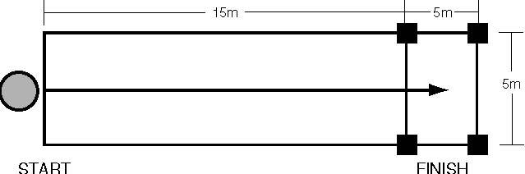
Equipment
Size four or size five balls, tape or chalk, four large cones to mark the finish zone.

Description
The player dribbles from the starting line to the finish zone, staying inside the marked lane. The finish zone should be marked off with cones as well as chalk. The clock is stopped when both the player and the ball are stopped inside the finish zone. If the player overshoots the finish zone, he/she must dribble it back in to finish.
Scoring
The time (in seconds) elapsed while the player is dribbling is converted into points using the scale below. A deduction of five points is made for each time the ball runs over the sidelines of the lane or if a player touches the ball with his/her hands (note: If the ball runs over the sideline, the referee will immediately place another ball in the center of the lane opposite the point at which the ball went out).

Scoring conversion chart

Dribble Time (Seconds) | Point Score
5–10 ....................... | 60 points
11–15 ..................... | 55 points
16–20 ..................... | 50 points
21–25 ..................... | 45 points
26–30 ..................... | 40 points
31–35 ..................... | 35 points
36–40 ..................... | 30 points
41–45 ..................... | 25 points
46–50 ..................... | 20 points
51–55 ..................... | 15 points
55 or more ............. | 10 points

Event 2: Shooting
FOOTBALL
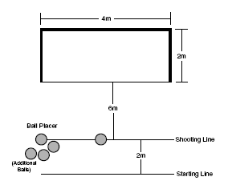
Equipment
Size four or size five balls, tape or chalk, four meter by two meter five-a-side goal with net.

Description
Athlete begins at the start line and walks or runs forward to shoot the ball into the goal from a distance of six meters. Athlete is only allowed to kick the ball once. The athlete returns to the line. Ball placer (official) places the next ball to be shot. Athlete repeats. Total of five shots. When the player kicks the last ball, the clock is stopped at a maximum of two minutes.

Scoring
Each successful goal scores 10 points

Event 3: Run and Kick
BALL
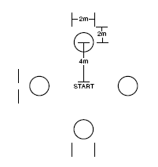
Equipment
Four, size four or size five, balls. A central starting point should be marked. A two-meter wide target gate (cones or flags) set up two meters ahead of each ball.

Description
Player begins at the starting marker. Athlete runs to any ball and kicks it through a target gate. Athlete is only allowed to kick the ball once. The player then runs and kicks another ball through a target gate. When the player kicks the last ball, the clock is stopped.

Scoring
The total time (in seconds) elapsed from when the player starts to when he/she kicks the last ball is recorded and converted into points using the conversion chart below.

A bonus of five points is added for each ball kicked successfully through a target gate

Scoring Conversion Chart

Dribble Time (Seconds) | Point Score
11–15 ..................... | 50 Points
16–20 ..................... | 45 points
21–25 ..................... | 40 points
26–30 ..................... | 35 points
31–35 ..................... | 30 points
36–40 ..................... | 25 points
41–45 ..................... | 20 points
46–50 ..................... | 15 points
51–55 ..................... | 10 points
55 or more ............ | 5 points

