Individual Skills
Purpose
Individual Skills Competition is not designed for athletes who can already play the game.
Score
The athlete’s final score is determined by adding together the scores achieved in each of these three events.
Personnel
Each event is diagrammed with the suggested number and placement of volunteers who will administer them. It is also suggested that the same tosser remain at an event throughout the competition so that consistency is provided.
Events
Three events comprise the Individual Skills Competition: overhead passing (volleying), serving and passing (forearm passing).

Event 1: Overhead Passing (Volleying)
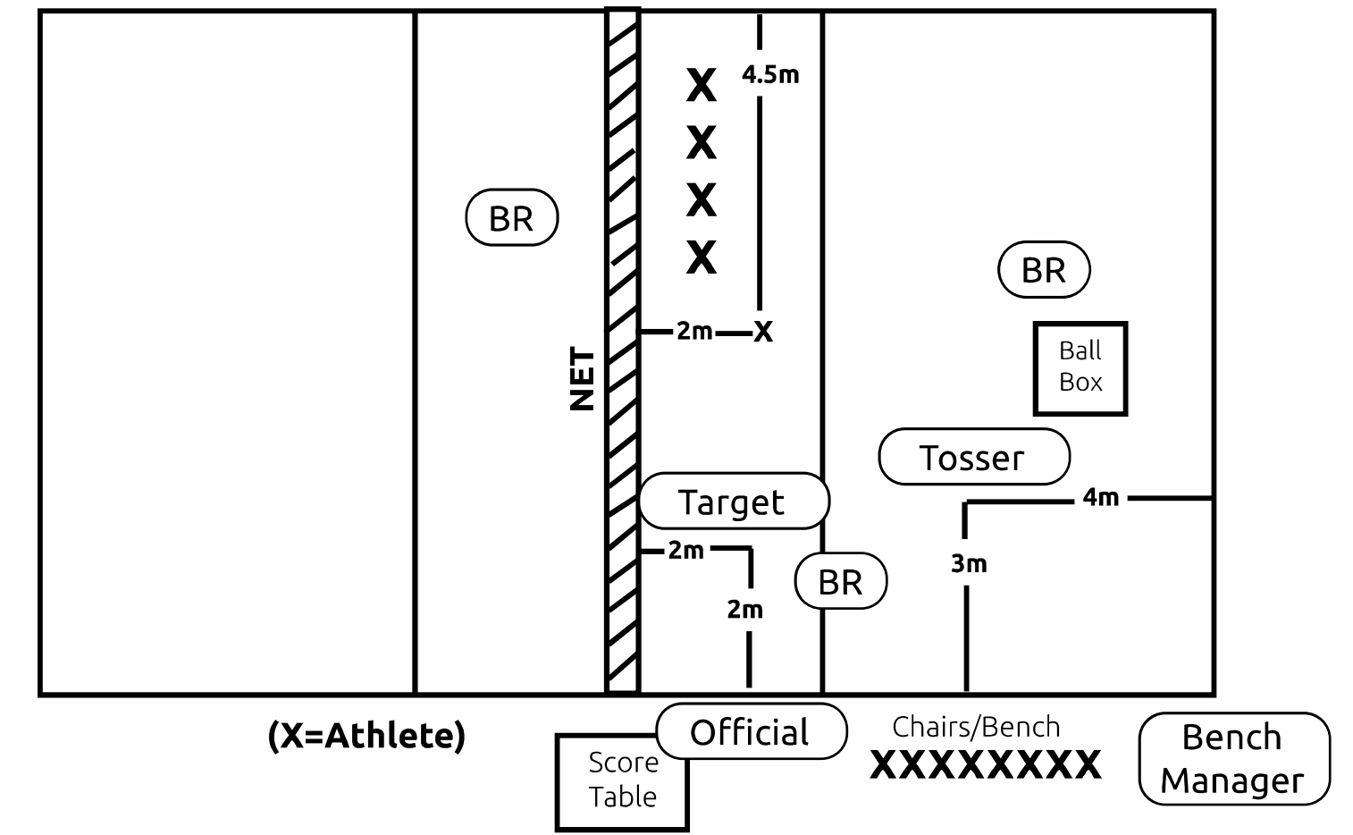

Diagram terms
Athlete
Official
Target
Ball Retriever (BR)
Tosser
Score Table
Bench Manager
Chairs/Bench
Ball Box
Net
Purpose
To measure an athlete’s ability to overhead pass (volley) the ball with consistency and at a height that could be spiked.
Equipment
Use a regulation-size court that is 18 meters (59 ft.) long and 9 meters (29ft, 6 in) wide, four volleyballs (modified ball permissible), net height at 2.24 meters (7 ft., 4 1/8 in) for women and 2.43 meters (7 ft., 11 5/8 in) for men, standards, antennae and ball box.
Description
Player is given 10 attempts from the center front position that is two meters (6 ft., 6 3/4 in) from the net and 4.5 meters (14 ft., 9 in) from the sideline.
The player receives 10, two-handed, underhand-tossed balls from the tosser who is positioned in his/her backcourt, four meters (13 ft., 1 1/2 in) from the baseline and three meters (9 ft., 10 in) from the sideline in the left back position.
The player sets the tossed ball toward a target (a person who has his/her hands above the head and who is standing two meters from the net and two meters from the sideline in the left front position).
Tosses that are not high enough for the athlete to set are repeated. The goal is for the peak of the arc of each set ball to be above net height.
Scoring
The peak of the arc of each set ball toward the target is measured.
The athlete will receive one point for volleying/setting the ball one meter (3 ft., 3 1/3 in) above his/her head height and three points for volleying/setting the ball above net height.
The following result in zero points: illegal contact, balls which go lower than head high and balls which go over the net or outside the court.
The athlete’s final score is determined by adding together the points awarded for each of the 10 attempts. It is suggested that the official stand on a chair to evaluate the height of each set.
Event 2: Serving
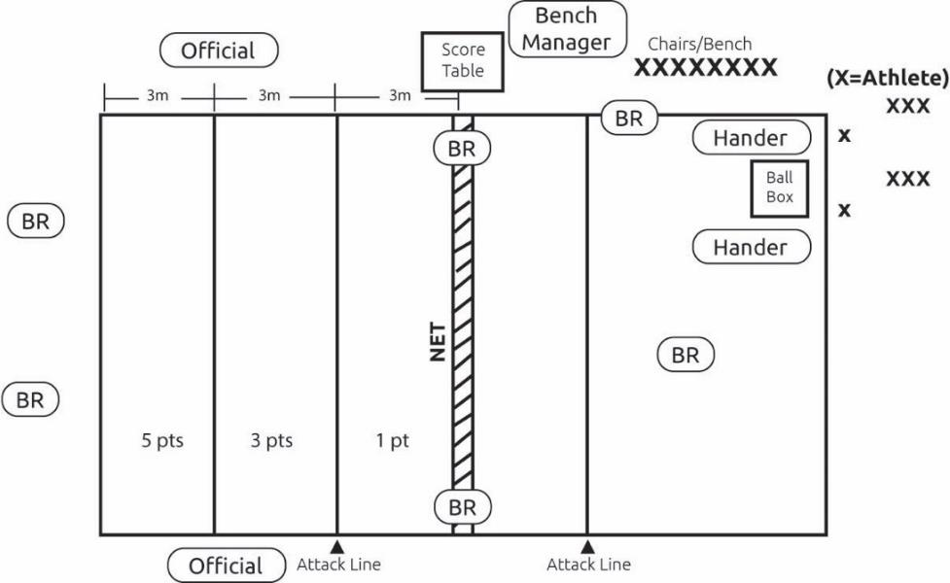
Diagram terms
Athlete
Official
Ball Retriever (BR) - roll balls back to Ball Retrievers at ball box
Score Table
Bench Manager
Chairs/Bench
Ball
Box
Net
Attack Line
Hander
Purpose
To measure the athlete’s ability to serve the volleyball over the net and into the opponent’s court.
Equipment
Use a regulation-size court that is 18 meters (59 ft.) long and 9 meters (29ft, 6 in) wide, five volleyballs (modified ball permissible), net, standards, antennae, measuring tape, floor tape or chalk and ball box.
Description
The athlete stands 1.5 meters (4 ft. 11 in) inside the end line and serves 10 volleyballs, one at a time, into the opponent’s court.
Scoring
The court is divided into three equal areas of 3 meters (9 ft. 10 in) in width. Each of these areas is assigned a different point value. The athlete’s score is the cumulative point total of the 10 serves. A ball which lands on the line is assigned to the area with the highest point value.
VOLLEYBALL
SPORT

Event 3: Passing (Forearm Passing)
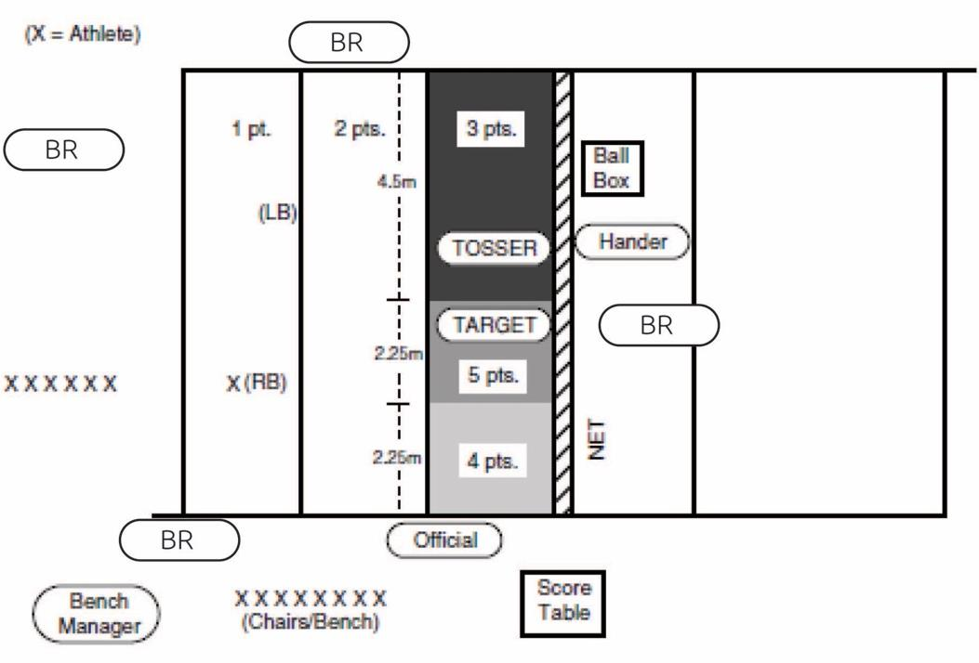
Diagram terms
Athlete
Official
Target
Score Table
Ball Retriever (BR)
Tosser
Hander
Bench Manager
Chairs/Bench
Ball
Box
Net
LB (left back)
RB (right back)
Purpose
To measure the athlete’s passing accuracy, height and consistency using
the forearm pass technique.
Equipment
Use a regulation-size volleyball court that is 18 meters (59 ft.) long and 9meters (29 ft., 6 in) wide, five volleyballs (modified ball permissible), net, standards, measuring tape, marking tape, and ball box.
Description
The athlete stands at the right back position, three meters (9 ft. 10 in) from the right sideline and one meter (3 ft. 3 1/3 in) from the baseline. A ball is thrown, using a two-hand, overhead toss by a coach/official who is standing on the same side of the net in the center front position, two meters (6 ft., 6 3/4 in) from the net. The athlete receives the toss and passes the ball toward a target (a person who has his/her hands above the head and who is standing on the same side, two meters [6 ft. 6 3/4 in] away from the net, and four meters [13 ft., 1 1/2 in] from the sideline away from the tossed). Target areas of varying point values are marked on the front court. The event is repeated with the athlete at the left back position, three meters from the left sideline and one meter from the baseline.
Scoring
the athlete must pass the ball so that the peak of the arc is at least net height in order to receive maximum points. A ball which lands on the line is assigned to the area with the higher point value. A ball which is passed below net height will receive only one point, regardless of where it lands. The athlete’s final score is determined by adding together the points scored from his/her five attempts at both the right back and the left back positions. It is suggested that the official stand on a chair to evaluate the height of each pass

