INDIVIDUAL SKILLS COMPETITION BASKETBALL LEVEL 1
There are 2 levels of Individual Skills Competition
Level I:
Three events make up Level 1 Individual Skills Competition: Target Pass, 10 Meter Dribble and Spot Shot. The athlete’s final score is determined by adding together the scores achieved in each of these three events.
Athletes will be pre-divisioned according to their total scores from these three events.
Each event is diagrammed with the suggested number and placement of volunteers who will
administer them. It is also suggested that the same volunteers remain at an event throughout the competition so that consistency is provided.

Event 1: Target Pass

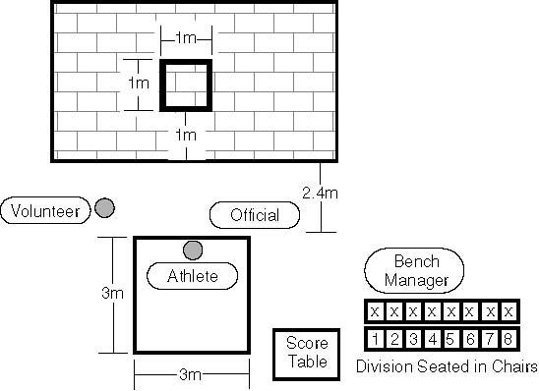

Purpose: to measure an athlete’s skill in passing a basketball.
Equipment
Two basketballs (for women’s and junior division competitions, a smaller basketball of 72.4 centimeters [28 1/2 in] in circumference and between 510–567 grams [18–20 oz] in weight may be used as an alternative), flat wall, chalk or floor tape, and measuring tape.
Description
A 1 meter (3 ft. 3 1/2 in) square is marked on a wall using chalk or tape. The bottom line of the square shall be 1 meter (3 ft., 3 1/2 in) from the floor. A 3 meter (9 ft., 9 in) square will be marked on the floor 2.4 meter (7 ft.) from the wall. The athlete must stand within the square. The leading wheel axle of an athlete’s wheelchair may not pass over the line. The athlete is given five passes.
Scoring
- The athlete receives three points for hitting the wall inside the square.
The athlete receives two points for hitting the lines of the square.
- The athlete receives one point for hitting the wall but not in or on any part of the square.
- The athlete receives one point for catching the ball in the air or after one or more bounces while standing in the box.
- The athlete receives zero points if the ball bounces before hitting the wall.
- The athlete’s score will be the sum of the points from all five passes.

Event 2: 10 M Dribble
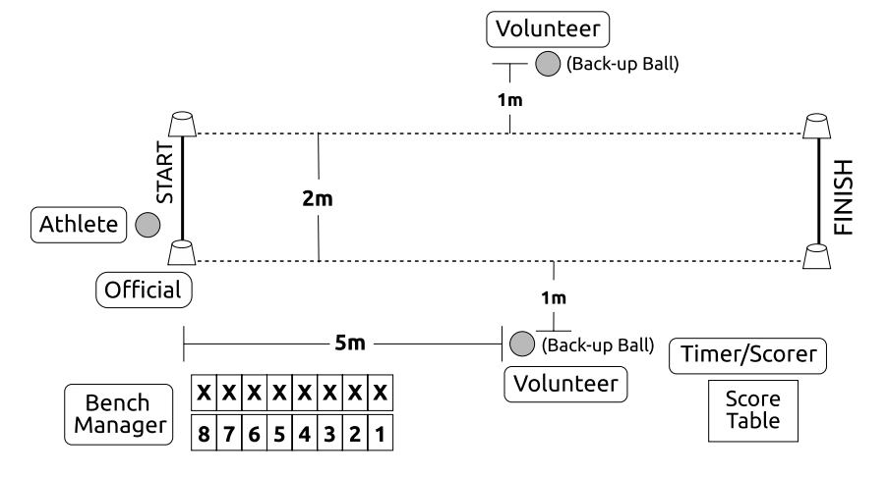
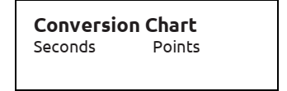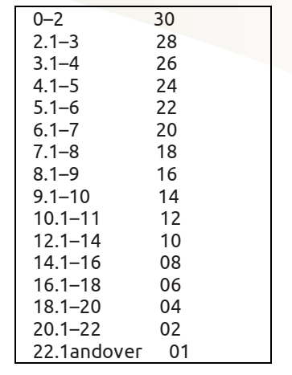
Purpose: To measure an athlete’s speed and skill in dribbling a basketball.
Description
The athlete begins from behind the start line and between the cones. The athlete starts dribbling and moving when the official signals. The athlete dribbles the ball with one hand for the entire 10 meter (32 ft. 9 ¾ in). A wheelchair athlete must alternate, taking two pushes followed by two dribbles for legal dribbling. The athlete must cross the finish line between the cones and must pick up the basketball to stop the dribble. If an athlete loses control of the ball, the clock continues to run. The athlete can recover the ball. However, if the ball goes outside the 2 meter lane, the athlete can either pick up the nearest back-up basketball or recover the errant ball to continue the event.
Scoring
The athlete will be timed from the signal “Go” to when he/she crosses the finish line between the cones and picks up the basketball to stop the dribble.
- A one-second penalty will be added every time the athlete illegally dribbles (e.g., two-hand dribbles, carries the ball, etc.).
- The athlete will receive two trials. Each trial is scored by adding penalty points to the time elapsed and converting the total to points based on the Conversion Chart. The athlete’s score for the event is his/her best of the two trials converted into points. (In case of a tie, the actual time will be used to differentiate place).

Event 3: Spot Shot
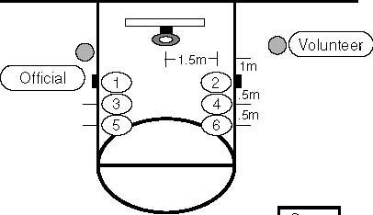
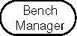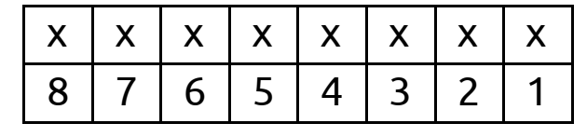

Purpose: to measure an athlete’s skill in shooting a basketball.
Equipment
Two basketballs (for women’s and junior divisions competitions, a smaller basketball of 72.4 centimeter [28 1/2 in] in circumference and between 510- 567 gram [18-20 oz.] in weight may be used as an alternative), floor tape or chalk, measuring tape and a 3.05 meter (10 ft.) regulation goal with backboard (for junior division competitions, a 2.44 meter [8 ft.] goal may be used as an alternative). Six spots are marked on the floor. Start each measurement from a spot on the floor under the front of the rim. The athlete attempts two field goals from each of six spots. The attempts are taken at spots #2, #4 and #6, and then at spots #1, #3 and #5.

The spots are marked as follows:
#1 & #2=1.5 meter (4 ft. 11 in) to the left and right plus 1 meter (3 ft. 3 ½ in) out
#3 & #4 =1.5 meter (4 ft., 11 in) to the left and right plus 1.5 meter (4 ft., 11 in) out.
#5 & #6 = 1.5 meter (4 ft., 11 in) to the left and right plus 2 meter (6 ft., 6 3/4 in) out.
Scoring
- For every field goal made at spots #1 and #2, two points are awarded.
- For every field goal made at spots # 3 and #4, three points are awarded.
- For every field goal made at spots # 5 and #6, four points are awarded.
- For any field goal attempt that does not pass through the basket but does hit either the backboard and/or the ring, one point is awarded.
- The athlete’s score will be the sum of the points from all 12 shots.
- The athlete’s final score for the Individual Skills Contest is determined by adding together the scores achieved in each of the three events.

