LEVEL I - INDIVIDUAL SKILLS COMPETITION RULES
Purpose
The purpose of the Individual Skills Competition is to allow athletes to train and compete in basic golf skills. The development of these key skills is necessary prior to advancing to Level 2-5. A maximum of 140 points may be scored in Level I, if the bunker shot is included. An example of the Individual Skills Competition Scoresheet can be found in the Addendum to the Golf Rules.
Point of Emphasis
For the following skills events: short putt, long putt, chip shot, pitch shot, bunker shot. When taking your 5 attempts and movement of the ball occurs, you should remove the ball prior to the next attempt to avoid interference.

Event 1: Short Putt (Maximum 20 points)

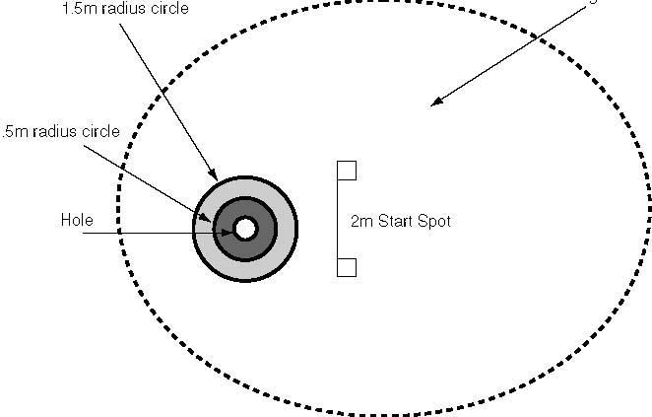

Purpose: To measure the athlete’s ability to putt, focusing on the Short Putt.
Equipment
- A regulation putting green with a properly marked (target) hole.
- Five balls.
- A chalker may be used to mark the circle targets around the hole
Description
- A target hole is selected and two circles are placed around the hole. The first circle shall have a radius of 0.5 meter and the second shall have a radius of 1.5 meters from the hole.
- The athlete will have five attempts from a clearly marked spot, 2 meters from the hole.
- The short putt should be set up on a green with as flat a surface as possible.
Scoring
- The athlete will have five attempts to putt the ball at the hole from a line 2 meters (6.56 feet) from the hole, scoring points according to where the ball comes to rest.
- The athlete will score one point for making a stroke at, and striking the ball. (A swing and a miss count as one attempt, and the athlete receives a score of zero).
- A second point is scored if the ball stops on or within the 1.5 meter (4.92 feet) circle.
- A third point is scored if the ball stops on or within the 0.5 meter (1.64 feet) circle.
- If the ball goes in the hole, a total of four points will be awarded for that attempt.
- The Short Putt score shall be the sum total of the five attempts

Event 2: Long Putt (Maximum 20 points)

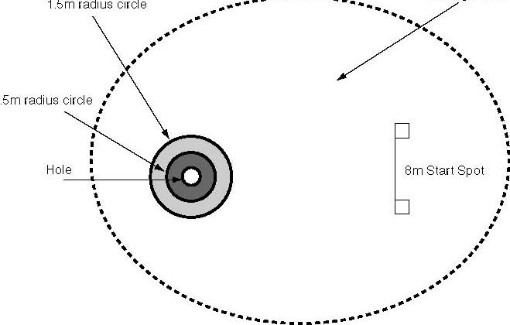

Purpose
To measure the athlete’s ability to putt, focusing on the Long Putt.

Equipment
- A regulation putting green with a properly marked (target) hole.
- Five balls.
- A chalker may be used to put target circles around the hole.

Description
- A target hole is selected and two circles are placed around the hole. The first circle shall have a radius of 0.5 meter and the second shall have a radius of 1.5 meter from the hole.
- The athlete will have five attempts from a marked spot, 8 meters from the hole.
- The Long Putt should be set up on a green with as flat a surface as possible. Note: Putting up hill is recommended.

Scoring
- The athlete will have five attempts to putt the ball at the hole from a spot 8 meters from the hole, scoring points according to where the ball comes to rest.
- The athlete will score one point for making a stroke at, and striking the ball. (A swing and a miss count as one attempt, and the athlete receives a score of zero).
- A second point is scored if the ball stops on or within the 1.5 meter circle.
- A third point is scored if the ball stops on or within the 0.5 meter circle.
- If the ball goes in the hole, a total of four points will be awarded for that attempt.
- The long putt score shall be the sum total of the five attempts.

Event 3: Chip Shot (Maximum 20 points)

6 meter radius circle

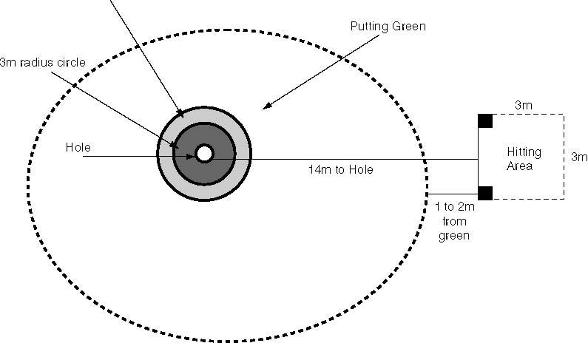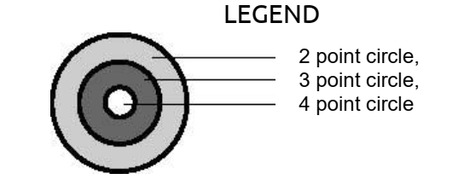

Purpose
To measure the athlete’s ability to hit chip shots 14 meters from the hole. Woods and putters are not permitted for this skill.

Equipment
- An appropriate number of golf balls based on the number of competitors (it is recommended that five balls per player be available to eliminate having to retrieve balls)
- A putting green with a clearly marked target flag and hole.

Description
- A chipping area is set up which includes a 3 meters by 3 meters square hitting area 14 meters from the hole. The chipping area should be 2 meters from the edge of the green.
- A 3-meter radius circle and a 6-meter radius circle will be placed around the hole.
- A safely marked hitting area, 3 meters by 3 meters square, chalk and marker.
- The athlete is instructed to chip the ball at a designated hole, getting it as close to the hole as possible.

Scoring
- The athlete will attempt five shots at the target, scoring points according to where the ball comes to rest.
- The athlete will score one point for making a stroke at and striking the ball. (A swing and a miss count as one shot and the athlete receives a score of zero for that shot).
- A second point is scored if the ball comes to rest inside the 6-meter (19.68 feet) circle around the hole.
- A third point is scored if the ball comes to rest inside the 3 meter (9.84 feet) circle around the hole.
- A fourth point is scored if the chip shot comes to rest in the hole.
- The total score from the five attempts will be the athlete’s final score for the Chip Shot.

Event 4: Pitch Shot (Maximum 20 points)

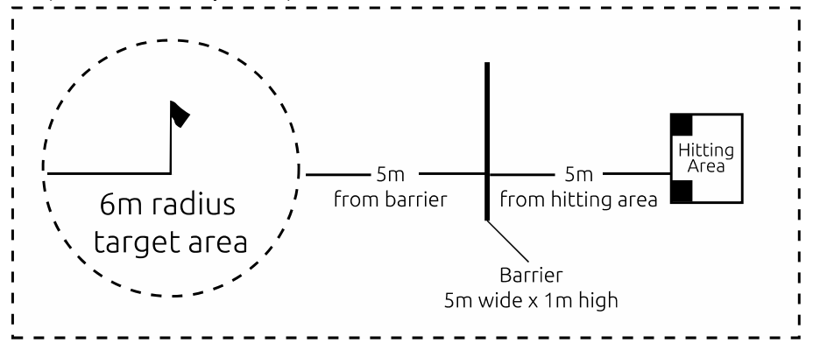

Purpose
To measure the athlete’s ability to hit controlled pitch shots in the air in the proper direction to a defined circular target area.

Equipment
- An appropriate number of golf balls based on the number of competitors (it is recommended that five balls per player be available to eliminate having to retrieve balls)
- A marked hitting area; paint, chalk, or cones.
- Shag bags or tubes to retrieve balls at station.
- A target flag and hitting mat or artificial surface.
- A banner, sign, net or barrier that measures one meter (3.28 ft) high by five meters (16.40 ft) wide. Two two-meter (6.56 ft) poles can be used to support the banner, sign, net or barrier.

Description
- A target area shall be a circle with a six-meter (19.68 ft) radius.
- The distance from the hitting area to the one-meter (3.28 ft) high barrier shall be five meters (16.40 ft).
- The distance from the one-meter (3.28 ft) high barrier to the target area shall be five meters (16.40 ft).
- The athlete shall make five attempts. The athlete is instructed to pitch the ball over the barrier at the designated target area.
- Note: The skill station should be located in a restricted area such as the driving range in order to provide the safest environment. If an unrestricted area is used, then the area should be roped off and clearly identified for volunteers, spectators and athletes.

Scoring
- The athlete will attempt five shots at the target, scoring points according to where the ball lands.
- Athletes will score one point for making a stroke at and striking the ball. (A swing and a miss count as one shot and the athlete receives a score of zero for that shot).
- A second point is scored if the ball goes over the barrier and between the upright poles.
- A third point is scored if the ball lands inside the 6-meter circle and rolls out, or if the ball lands outside the 12-meter circle and comes to rest inside the circle.
- A fourth point is scored if the ball lands inside the 6-meter circle and comes to rest inside the circle.
- The Pitch Shot score shall be the sum total of the five attempts.

Event 5: Iron Shot (Maximum 20 points)

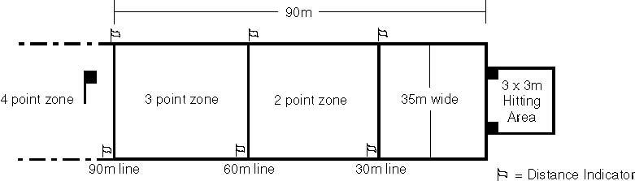

Purpose
To measure the athlete’s ability to hit an iron shot for distance within a set hitting area.

Equipment
- An appropriate number of golf balls based on the number of competitors (it is recommended that five balls per athlete be available to eliminate having to retrieve balls).
- Marking paint or chalk, and marker to mark hitting area and boundary lines (1/2-inch cord or rope can be substituted for marking boundary lines, making them more visible).
- Hitting mat or carpet, tees, helmets, a safety zone for scorekeepers to stand in and shag bags or tubes to retrieve balls (if necessary); and
- A target flag and eight cones or other visible markers to identify distance locations.
- Athletes may use an Iron or Hybrid/Rescue Club for either an Iron shot, but not both.

Description
The athlete may choose to hit the ball off a tee, a mat or the ground. The athlete is instructed to hit the ball from the teeing area toward a designated flag in the hitting area, trying to keep the ball within the boundary markers and achieving a distance of more than 90 meters.

Scoring
- The athlete will attempt five shots at the target, scoring points according to where the ball comes to rest.
- Athletes will score one point for making a stroke at and striking the ball. (A swing and a miss count as one attempt and the athlete receives a score of zero for that shot).
- Two points are scored for a ball that comes to rest between the 30 meter and 60 meter lines within the 35-meter wide boundary lines.
- Three points are scored for a ball that comes to rest between the 60 meter and 90 meter lines within the 35-meter wide boundary lines.
- Four points are scored for a ball that comes to rest beyond the 90 meters line within the 35-meters wide boundary lines.
- The athlete’s score for the Iron Shot shall be the sum total of the five attempts.

Event 6: Wood Shot (Maximum 20 points)

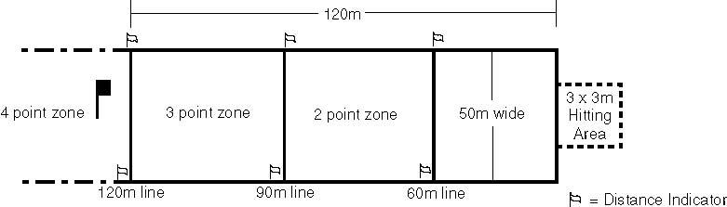

Purpose: To measure the athlete’s ability to hit a wood shot for distance within a set hitting area.

Equipment
- An appropriate number of golf balls based on the number of competitors (it is recommended that five balls per player be available to eliminate having to retrieve balls).
- Marking paint or chalk, and marker to mark hitting area and boundary lines (a 1/2-inch (1.27 cm) cord or rope can be substituted for marking boundary lines, making them more visible).
- Hitting mat or carpet, tees, helmets, a safety zone for scorekeepers to stand in and shag bags or tubes to retrieve balls (if necessary); and A target flag and eight cones or other visible markers to identify distance locations.
- Athletes may use a Fairway Wood, or Driver and if they did not use a Hybrid/Rescue Club for their iron shot, then they can use it for the Wood shot.

Description
The athlete may choose to hit the ball off a tee, a mat or the ground. The athlete is instructed to hit the ball from the teeing area toward a designated flag in the hitting area, trying to keep the ball within the boundary markers and achieving a distance of more than 120 meters.

Scoring
- The athlete will attempt five shots at the target, scoring points according to where the ball comes to rest.
- The athlete will score one point for making a stroke at and striking the ball (a swing and a miss count as one attempt, and the athletes receives a score of zero for that shot).
- Two points are scored for a ball that comes to rest between the 60 meter and 90 meter lines within the 50-meter wide boundary lines.
- Three points are scored for a ball that comes to rest between the 90 meter and 120 meter lines within the 50-meter wide boundary lines.
- Four points are scored for a ball that comes to rest beyond the 120 meters line within the 50-meters (164.041 feet) wide boundary lines.
- The athlete’s score for the Wood Shot shall be the sum total of the five attempts.

Event 7: Bunker Shot (Maximum 20 points)

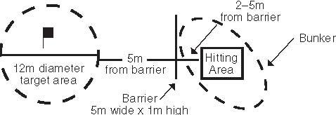

Optional Skill
This skill is considered optional and may be included in ISC at the discretion of the Program.

Purpose
To measure the athlete’s ability to hit controlled shots from a bunker in the air in the proper direction to a defined circular target area.

Equipment
- An appropriate number of golf balls based on the number of competitors (it is recommended that five balls per player be available to eliminate having to retrieve balls)
- A defined hitting area in a bunker or manufactured area with sand, paint or chalk, and markers;
- Shag bags or tubes to retrieve balls at station.
- A target flag, hitting mat or artificial surface covered with sands, paint, chalk or marker in the bunker from which to hit.
- The rim of the bunker (bunker face) should be at least one meter high and five meters wide. If not, a banner, net or barrier should be constructed such that from the bunker hitting area a ball must clear 1meter in height. Two two-meter support poles should be used to support the banner, sign, net or barrier. Poles should also be used to designate five meters scoring width on the bunker face.

Description
- A target area shall be a circle with a six-meter radius.
- The distance from the hitting area in the bunker to the one-meter barrier or bunker face shall be five meters.
- The distance from the one-meter high barrier or bunker face to the target area shall be five meters.
- The athlete shall make five attempts. The athlete is instructed to pitch the ball out of the sand and toward the designated target area.
- Note: The skill station should be located in a restricted area such as the driving range in order to provide the safest environment. If an unrestricted area is used, then the area should be roped off and clearly identified for volunteers, spectators and athletes.

Scoring
- The athlete will attempt five shots at the target, scoring points according to where the ball lands.
- Athletes will score one point for making a stroke at and striking the ball. (A swing and a miss, or “grounding” the club, counts as one shot and the athlete receives a score of zero for that shot).
- A second point is scored if the ball goes over the barrier or bunker face and between the upright poles.
- A third point is scored if the ball lands inside the 12-meter circle and rolls out, or if the ball lands outside the 12-meter circle and comes to rest inside the circle.
- A fourth point is scored if the ball lands inside the 12-meter circle and comes to rest inside the circle.
- The Bunker Shot score shall be the sum total of the five attempts.

